PGPCC Project

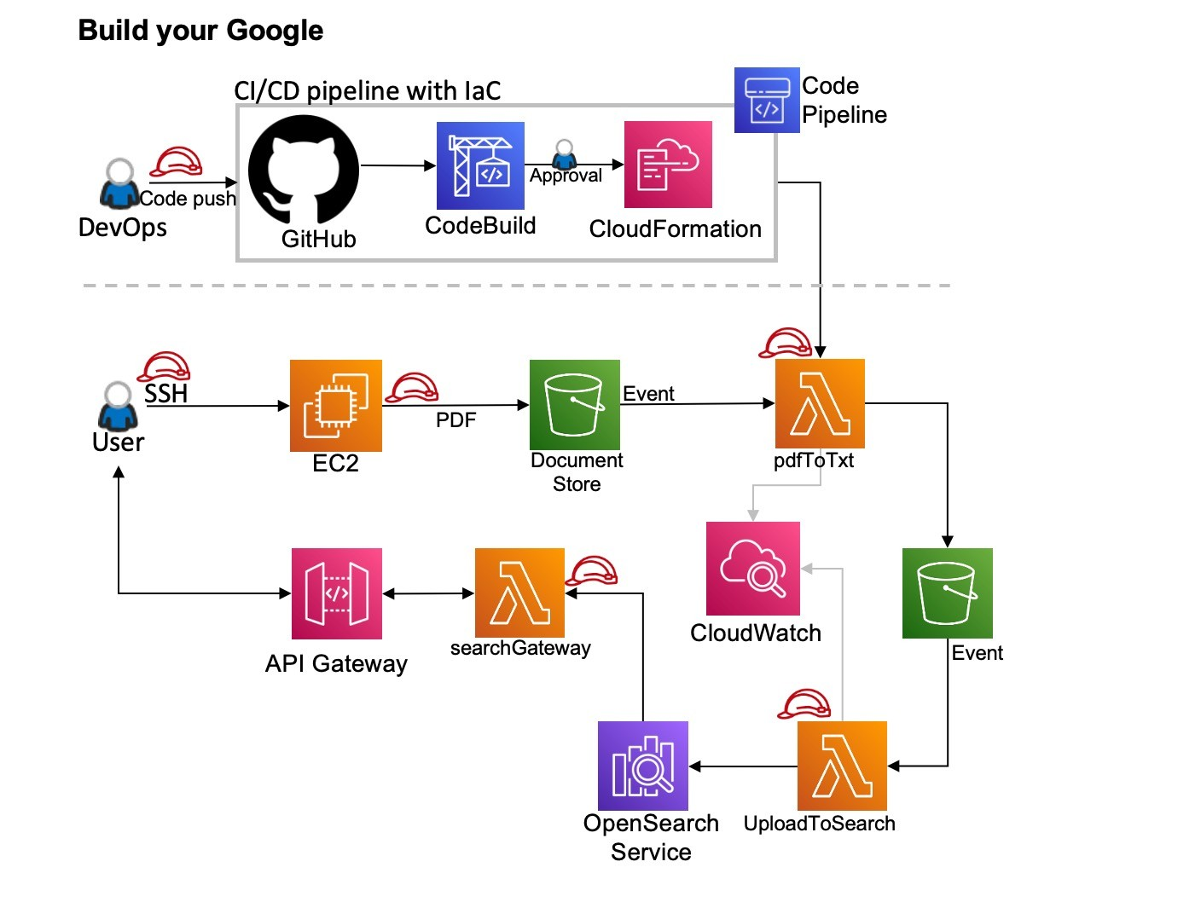
Steps for implementation
- Create an AWS Opensearch domain
- Download the deployment package files for the 4 Lambda functions provided along with this document on Olympus.
- Deploy these packages on CodePipeline using the SAM and buildspec files provided in the zipped package files after configuring the Lambda functions.
- Set up triggers for each of the Lambda functions created in the previous step
- Set up an API Gateway to access the Opensearch domain via the Lambda function ‘search-gateway’
- Upload the sample PDF file provided into the S3 bucket document store to chaintrigger the Lambda functions

Configuring Opensearch
- Create a new Opensearch Domain using the AWS console
- Select “VPC access” in the Network Section
- Fine grained access control section

- Ensure Fine-grained access control is turned on

- Create a Master User with a username and password

- Save the username and password
- Access Policy section
- select only use fine-grained access control
- Create an IAM role for AWS Lambda with permissions for Opensearch
- Login to Opensearch using the dashboard URL and enter your username and password
- In the dashboard click on the 3 lines upper left of page, navigate to Security
- Select Roles and then select the all access role
- Select Mapped users and then Manage mapping
- Select Backend roles, add Amazon Resource Name (ARN) from Lambda role
- Select Map and confirm the user or role shows up under Mapped users

Configuring Lambda Function 1 – pdftotxt
- This function convert the input PDF file into a text file

- This function triggers a S3 bucket PUT Event when a PDF file is uploaded to a S3 bucket

- The variable TARGET_BUCKET needs to be configured as an environmental variables with the name of the S3 bucket uses as intermediary storage
- Ensure that the function has the role which allows access to the other services

Configuring Lambda Function 2 - upload-to-search
- The purpose of this function is to process the text file generated by the previous Lambda function pdftotxt and add the text to Opensearch
- The trigger for this function is an S3 PUT Event into the S3 bucket being used as intermediary storage
- The handler for this function is in the file sample.py and is named handler which needs to be configured and points towards this handler function
- The region being used for this activity and the domain URL of the Opensearch domain created will need to be configured in the region and host variables.
- Ensure that the function has the role which allows access to the other services

Configuring Lambda Function 3- searchgateway
- The purpose of this function is to process the incoming HTTP requests from the API Gateway to run search queries on the Opensearch domain
- The trigger for this function is an API request from the API gateway created as part of this exercise
- The handler for this function is in sample.py and is named lambda_handler which the function runtime settings will need to be configured to point towards this handler function.
- Ensure that the function has the role which allows access to the other services

Configuring Lambda Function - 4searchFunction
- This function will receive the data entered into the search field and return the search results.
- The trigger for this function is an API request from the API gateway created as part of this exercise
- The region being used for this activity and the domain URL of the Opensearch domain created will need to be configured in the region and host variables.
- Ensure that the function has the role which allows access to the other service

Setting up GitHub
- Create a Github account or use an existing one
- Create an IAM user with programmatic access and create Github credentials for this user
- Install Gitbash terminal on your local machine
- Create an empty directory in your local machine and navigate to it using the terminal
- Use the git clone command and the HTTPS URL of the repository to set up the remote repository, use the previous created credentials
- Copy the Lambda function files into the directory created in Step 4. This includes the buildspec and SAM files as well. Use the git add, git commit and git push commands to push the files into the repository.
.
Setting up CodeBuild
- Create a new CodeBuild project using the AWS console
- Ensure that the project uses CodeCommit as the source and select the repository created previously
- Use the latest Standard Ubuntu CodeBuild 6.0 environment for the build environment
- Make sure to create a new service role for the project
- Create a new S3 bucket and use this bucket to store artifacts for the project

Setting up CodePipeline
- Create a new pipeline using the AWS console
- Select the GitHub repository created previously as the source for this pipeline
- Select the CodeBuild project created previously for the build stage
- Use CloudFormation as the deployment platform and ensure that the IAM role used for CloudFormation has access to S3 and AWS Lambda and the following capabilities
- CAPABILITY_IAM and CAPABILITY_AUTO_EXPAND are added to the list of CloudFormation’s capabilities
- Run the pipeline to deploy the Lambda function
- Set up separate CodeCommit repositories, CodeBuildprojects and pipelines for each of the Lambda functions provided.

Setting up API Gateway
- Create a new HTTP Gateway using the AWS console
- Under Integrations, add the Lambda functions search-gateway and searchFunction
- Under Routes, add the following route
- Method : Any, Route : / , Integration Target : search-gateway
- Method : Any, Route : /search , Integration Target : searchFunction

Final Steps
- Ensure that the IAM role attached to the Lambda functions pdftotxt and upload-tosearch have permissions for S3 access
- Ensure that the IAM role attached to the Lambda functions upload-to-search and searchFunction have permissions for Opensearch access
- SearchFunction uses the same IAM role created as part of the Opensearch setup
- Ensure that the triggers for all the Lambda functions have been configured as described in their individual sections in this document

Testing the deployment
- Upload the test PDF file provided with this document to the document store bucket created previously.
- Wait for a few minutes for each function to trigger in succession
- Monitored the function Cloudwatch log groups
- Access the search webpage by visiting the URL of the API Gateway created previously
- Search for any word in the sample PDF document and check for correctness in the output provide

